CAYMAN DINING SIDE CHAIR
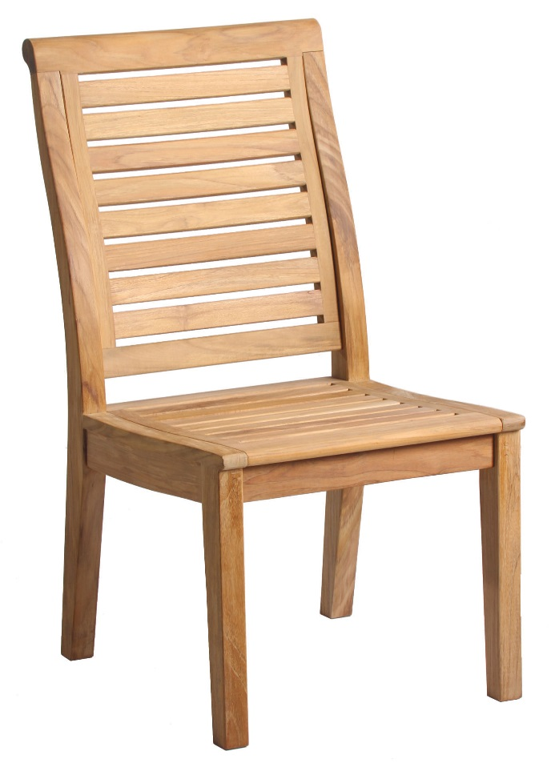
Depth: 21.5”
Width: 19.5”
Height: 36.6”
Weight: 20lbs
Part: DN-2256
Manufacturer: Douglas Nance
Material: Premium Grade A Teak
Country: Indonesia

For more information visit:
www.douglasnance.com

