CAYMAN DINING ARMCHAIR
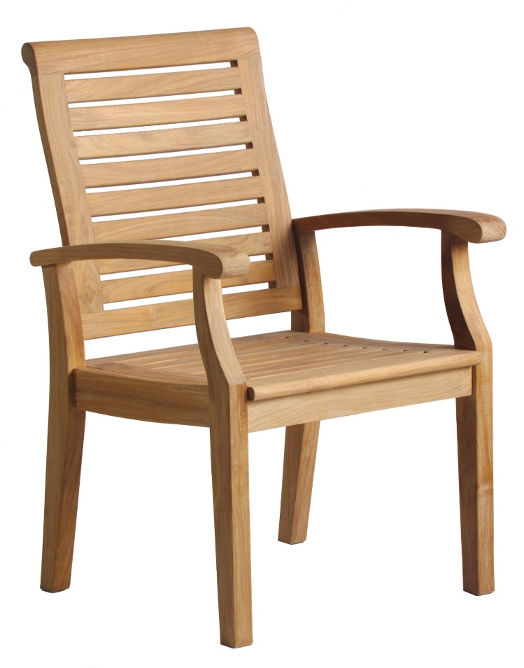
Depth: 21.5”
Width: 25”
Height: 36.6”
Weight: 24lbs
Part: DN-2255
Manufacturer: Douglas Nance
Material: Premium Grade A Teak
Country: Indonesia

For more information visit:
www.douglasnance.com

